**Cybersecurity-Homelab-Building-The-Environment Documentation:**

This guide provides step-by-step instructions with screenshots for key steps. Optional explanations are highlighted in red for clarity and can be skipped.

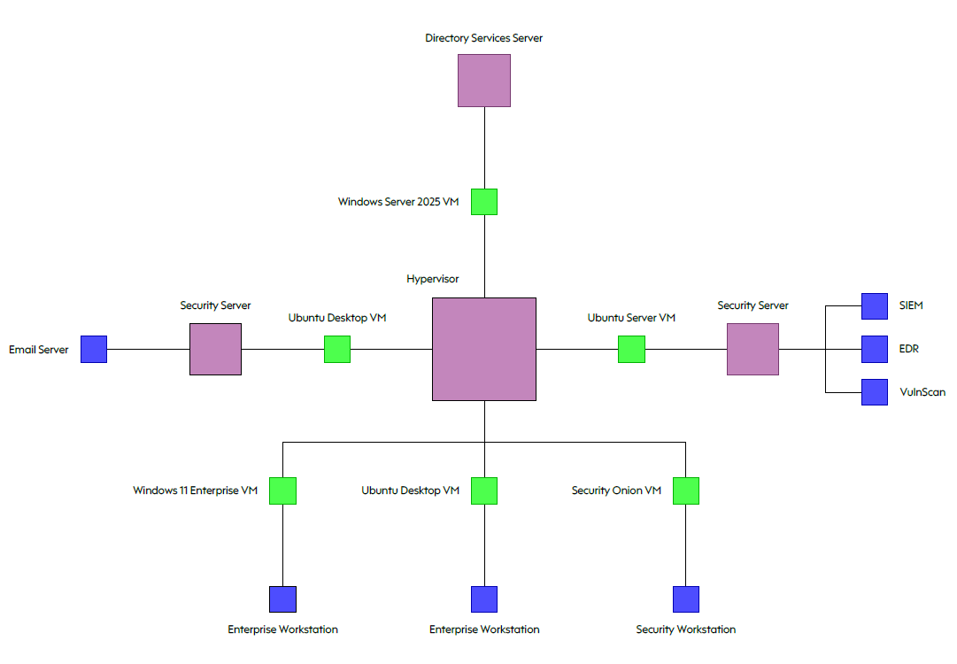Below is the network architecture for the small business lab:

|  |  |  |  |  |
| --- | --- | --- | --- | --- |
| *Element* | *Purpose* | *Software/OS* | *Specs* | *Storage (minimum)* |
| *Hypervisor.* | *Runs and manages multiple VMs* | *VirtualBox on Windows 11 host.* | *-* |  |
| *Enterprise Workstation 1* | *Employee workstation simulation* | *Windows 11 Enterprise VM* | *2 CPU / 4096 MB* | *80 GBs* |
| *Enterprise Workstation 2* | *Linux workstation simulation (developer/employee)* | *Ubuntu 22.04 Desktop VM* | *1 CPU / 2048 MB* | *80 GBs* |
| *Security Workstation* | *Security analysis and monitoring* | *Security Onion VM* | *1 CPU / 2048 MB* | *55 GBs* |
| *Security Server 1* | *Email environment for phishing exercises (MailHog/Postfix)* | *Ubuntu 22.04 Desktop VM* | *2 CPU / 4096 MB* | *80 GBs* |
| *Security Server 2* | *Central SIEM/EDR server, log collection, analysis, vulnerability scanning* | *Ubuntu Server 22.04 with Wazuh* | *1 CPU / 2048 MB* | *25 GBs* |
| *Directory Services Server* | *Central identity & network management (AD, DNS, DHCP, SSO)* | *Windows Server 2025* | *2 CPU / 4096 MB* | *50 GBs* |

**Step 1: Download ISOs For VMs:**

Install the operating system ISOs by downloading them from the links provided below:

* Windows Server 2025: <https://www.microsoft.com/en-us/evalcenter/evaluate-windows-server-2025>
* Windows 11 Enterprise: <https://www.microsoft.com/en-us/evalcenter/evaluate-windows-11-enterprise>
* Ubuntu Desktop 22.04.5 LTS: <https://releases.ubuntu.com/jammy/ubuntu-22.04.5-desktop-amd64.iso>
* Ubuntu Server 22.04.5 LTS: <https://releases.ubuntu.com/jammy/ubuntu-22.04.5-server-amd64.iso>
* Security Onion: <https://github.com/Security-Onion-Solutions/securityonion/releases>

*These ISO files contain the operating systems designated for installation on the virtual machines within the business network.*

**Step 2: Enable Virtualisation On PC:**

1. Restart your PC and enter the BIOS/UEFI using the manufacturer-specific hotkey.

2. Locate and enable Virtualization Technology (Intel VT-x / AMD-V).

3. Save changes and reboot.

*Virtualisation must be enabled to run virtual machines.*

**Step 3: Install Virtual Box:**

1. Download VirtualBox for host OS: <https://www.virtualbox.org/wiki/Downloads>

2. Windows hosts: Ensure Microsoft Visual C++ 2019 Redistributable is installed: <https://learn.microsoft.com/en-us/cpp/windows/latest-supported-vc-redist?view=msvc-170>

3. Install VirtualBox using default settings.

*VirtualBox is a type-2 hypervisor that allows you to run virtual machines on your computer.*

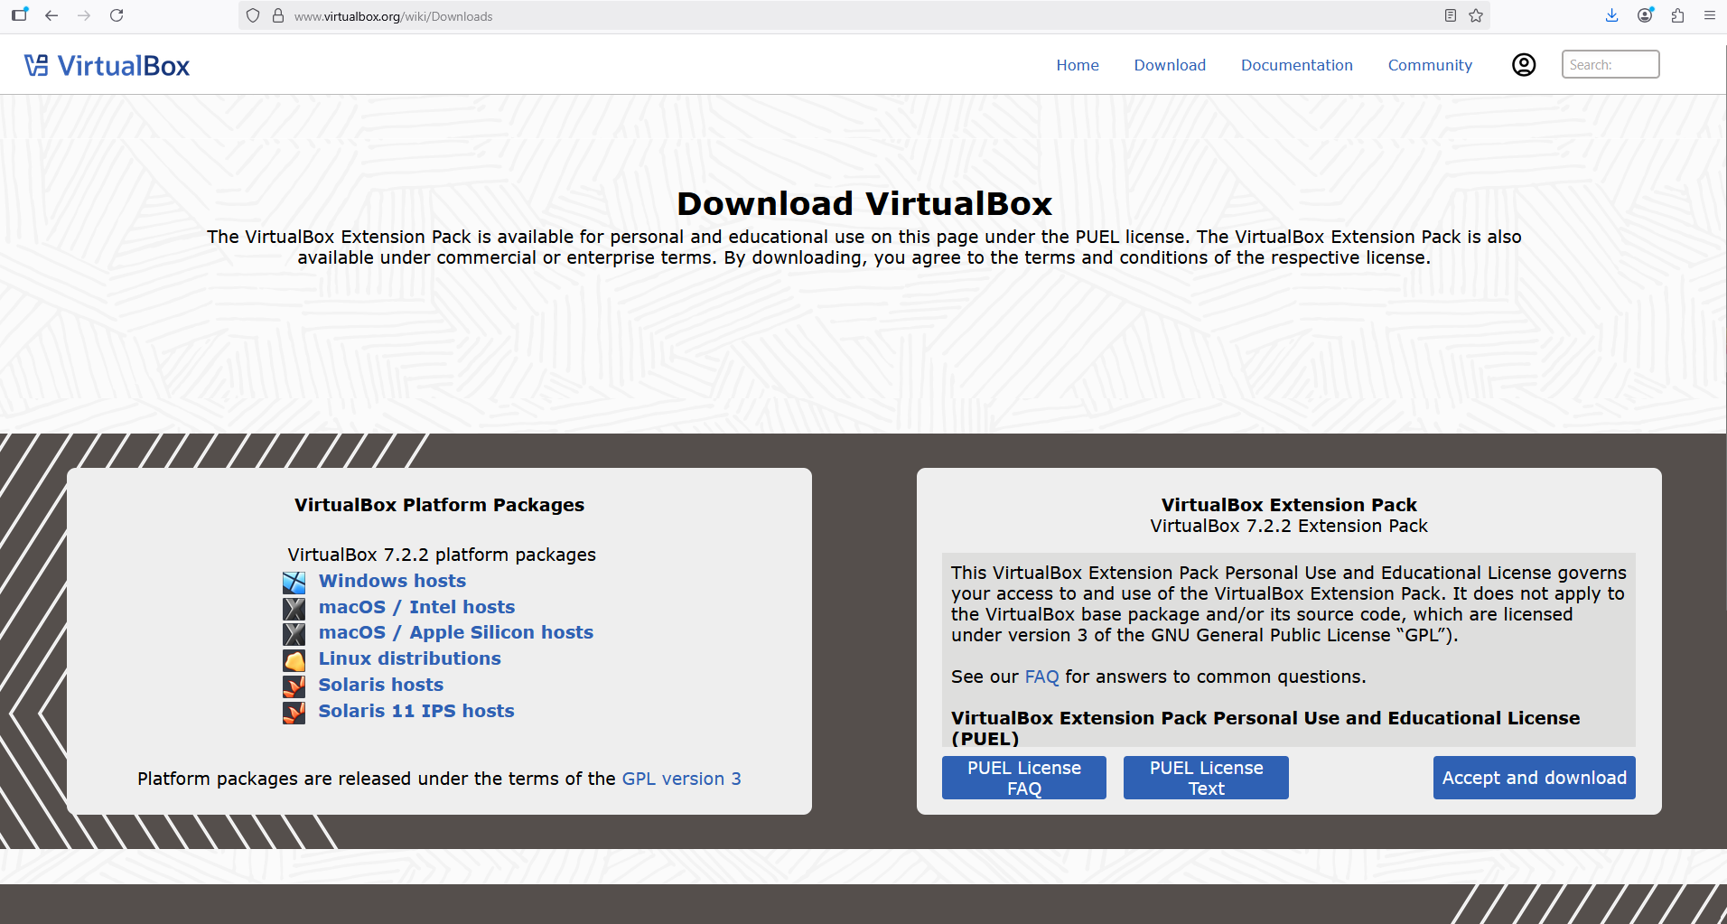

Step 4: Provision NAT Network On Vbox:

1. Switch VirtualBox preferences to Expert Mode to access the network menu.

2. Click the Network icon → NAT Networks → Add new network.

3. Name the network, set IPv4 Prefix to 10.0.0.0/24, enable DHCP, and click Apply.

*NAT Network: Allows VMs internet access while isolating them from the host network. Compromised VMs cannot reach your real network.*

*IPv4 Prefix /24: Provides 254 usable IPs (10.0.0.1–10.0.0.254) for lab VMs.*

*DHCP: Automatically assigns IPs to VMs, avoiding manual configuration.*

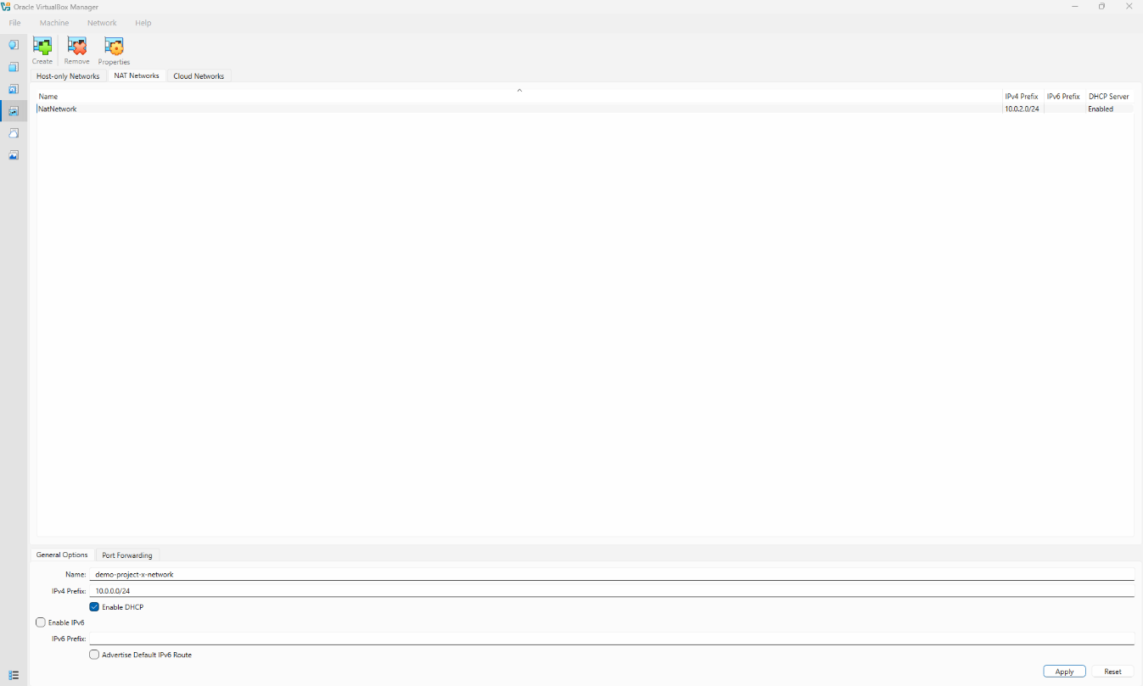

Step 5: Provisioning Windows Server 2025 VM (for Directory Services Server):

1. Create VM in VirtualBox:

- Name VM, Type: Microsoft Windows, Version: Windows 2022 (64-bit).

- Memory: 4096 MB, CPUs: 2, Hard Disk: 50 GB.

- Assign VM to the NAT network created earlier.

*Set up a virtual machine environment with sufficient resources to run Windows Server 2025 and lab services reliably.*

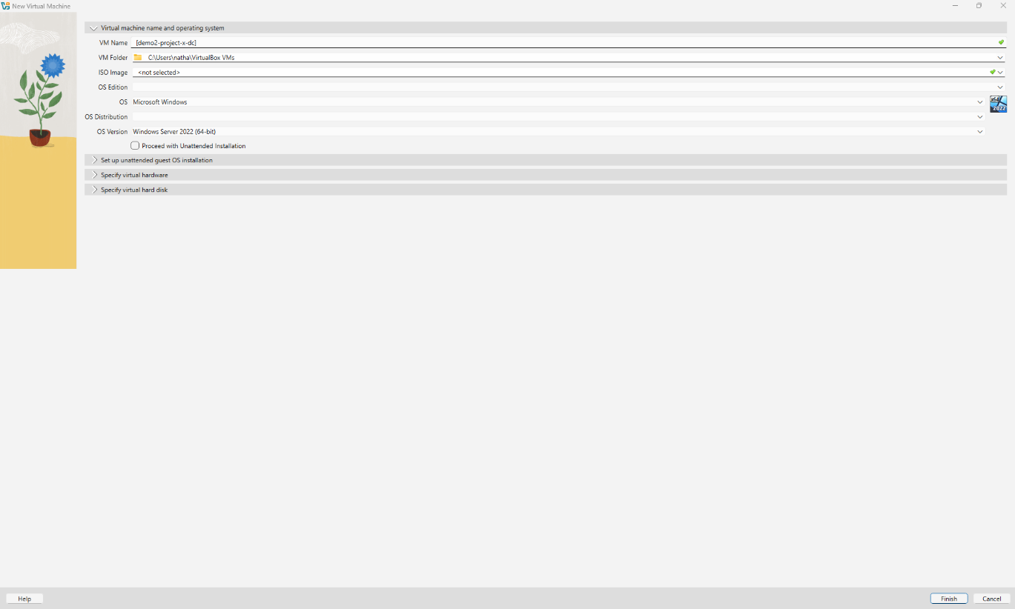

2. Mount ISO & Install OS:

- Boot from Windows Server 2025 ISO.

- Select language and region.

- Install Windows Server 2025 Standard Evaluation (Desktop Experience).

- Create a new partition (default settings) for system stability.

- Set Administrator password.

*Install the server OS to provide a base system for Active Directory, DHCP, DNS, and other lab services. Creating a partition separates system files from the OS for stability and recovery.*

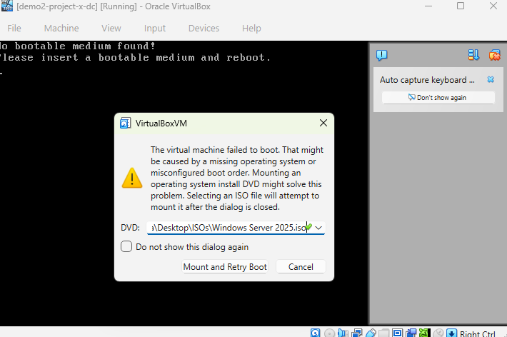

3. Convenience & Usability Configurations

- Disable auto logoff: Settings → Accounts → Sign-in options → “Require sign-in” set to Never.

- Disable Ctrl+Alt+Del requirement:

- Win + R → gpedit.msc → Computer Configuration → Windows Settings → Security Settings → Local Policies → Security Options → “Interactive logon: Do not require Ctrl+Alt+Del” → Enabled.

- Install VirtualBox Guest Additions: Devices → Insert Guest Additions CD → Run VBoxWindowsAdditions.exe → Reboot.

- Enable Full Screen, Shared Clipboard (bidirectional), Drag & Drop (bidirectional).

*Disabling auto logoff and Ctrl+Alt+Del simplifies uninterrupted access and login, while installing Guest Additions enables full screen, shared clipboard, and drag-and-drop functionality for improved efficiency.*

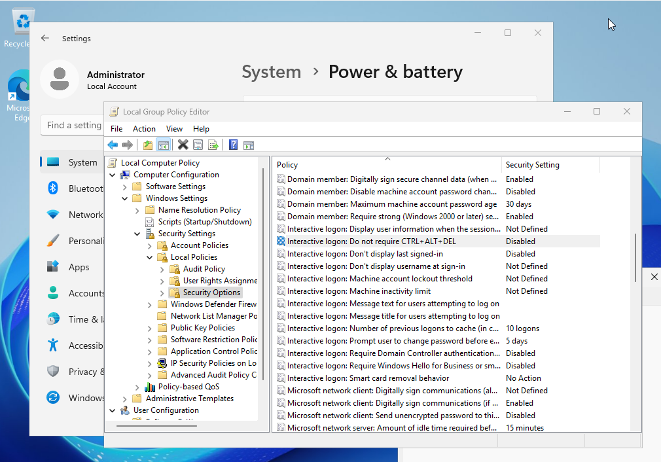

4. Assign Static IP

- Control Panel → Network & Internet → Network & Sharing Center → Change adapter settings → Ethernet → IPv4 properties.

- Set IP: 10.0.0.5, Subnet Mask: 255.255.255.0, Gateway: 10.0.0.1.

*Ensures consistent network addressing so that other VMs and services can reliably locate the directory server.*

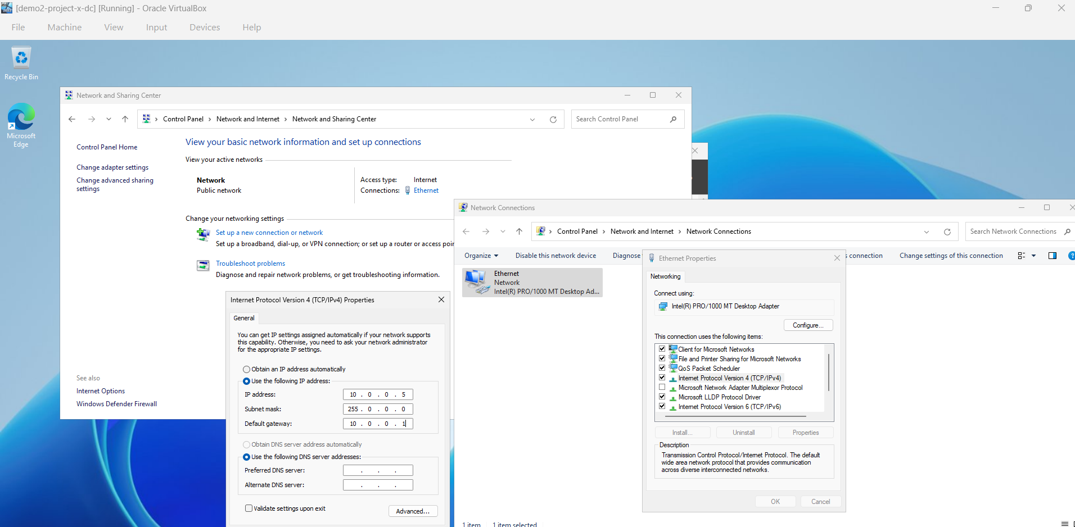

5. Install Server Roles

- Server Manager → Add Roles & Features → Role-based installation.

- Install: Active Directory Domain Services (AD DS), DHCP, DNS (all defaults).

*Deploy core network services (AD DS, DHCP, DNS) needed for lab operations, user authentication, and automated IP management.*

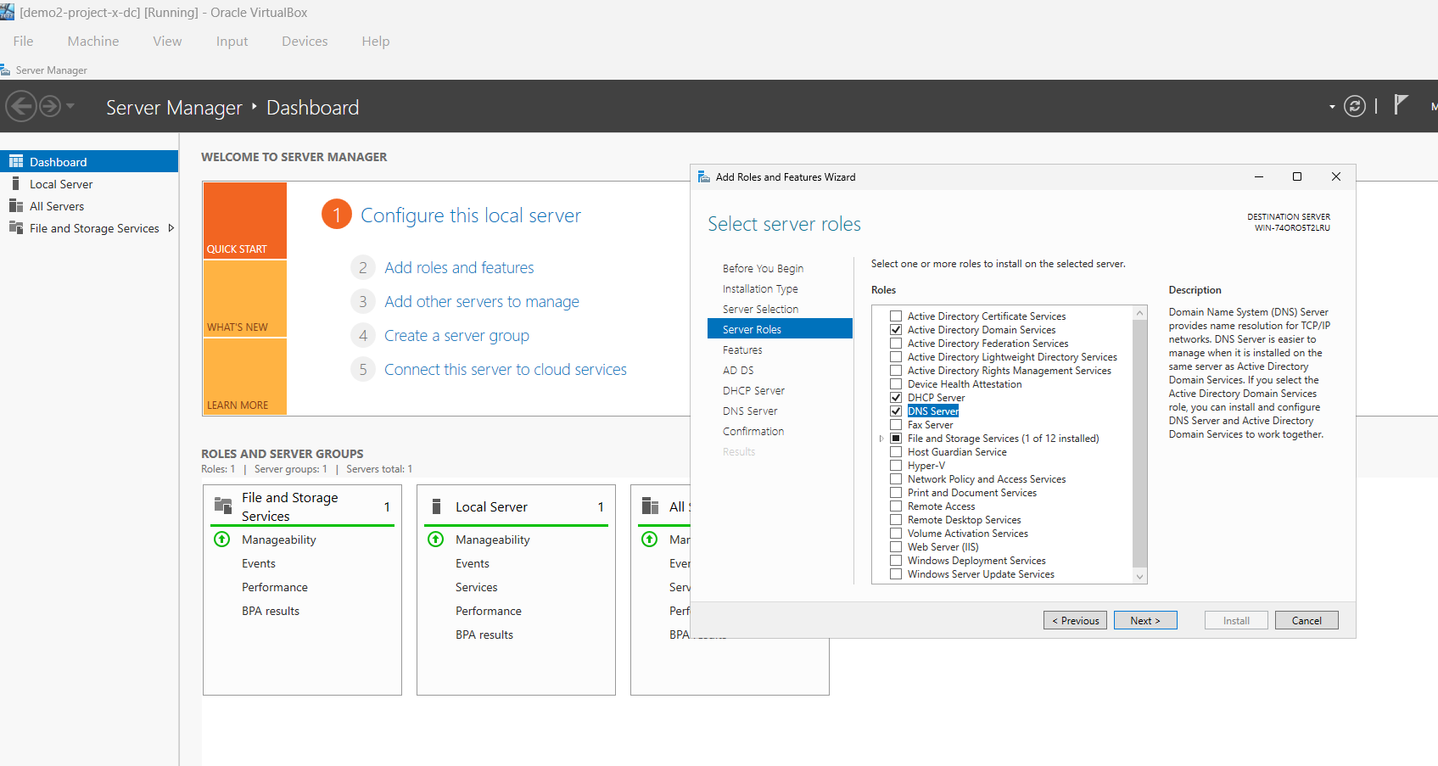

6. Promote to Domain Controller

- Server Manager → AD DS → Promote server to Domain Controller.

- Create new forest with root domain name (e.g., corp.project-x-dc.com).

- Set DSRM password, leave defaults for NetBIOS, paths, DNS options.

- Complete installation and restart VM.

*Enables the server to host and manage the Active Directory domain, providing centralized identity, authentication, and policy management for lab VMs.*

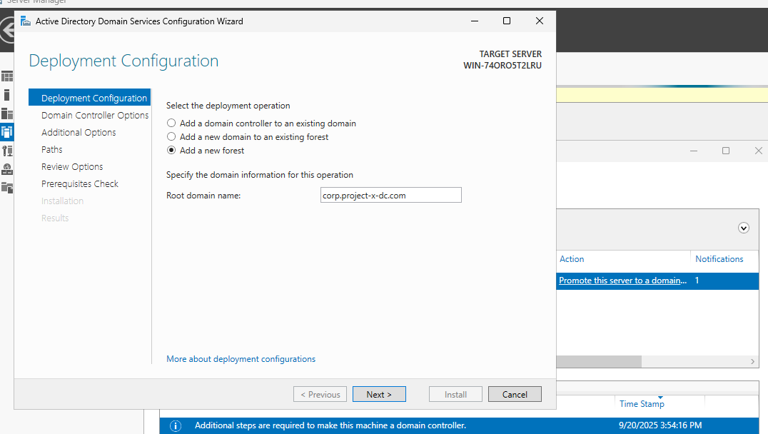

7. Configure DNS

- Server Manager → DNS → Forward Lookup Zone → Configure internal domain.

- Forwarders → Add external DNS (e.g., 8.8.8.8) for internet name resolution.

- Test connectivity: ping google.com and nslookup [domain].

*DNS: Resolves internal domain names and forwards external requests.*

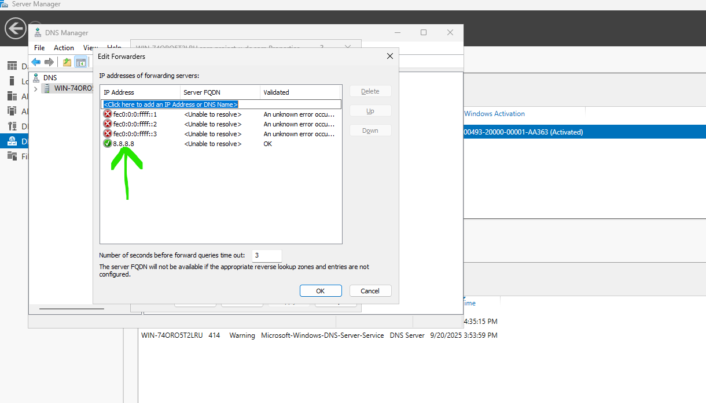

8. Configure DHCP

- DHCP → IPv4 → New Scope.

- Set Scope Name, IP Range: 10.0.0.100–10.0.0.200, Subnet: /24.

- Use defaults for exclusions, lease duration (8 days), and other options.

- Set default gateway: 10.0.0.1, complete DHCP configuration.

*DHCP: Dynamically assigns IPs to lab VMs within a defined range, preventing conflicts with static addresses*

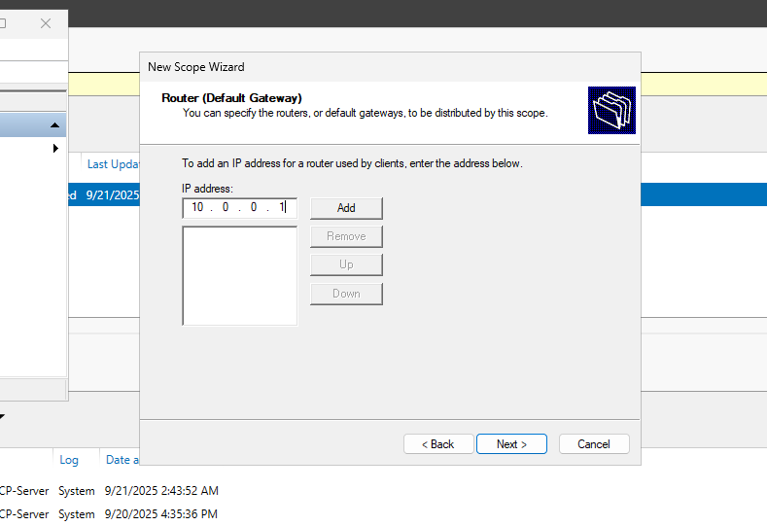

10. Create AD Users

- Server Manager → Tools → Active Directory Users and Computers → Users folder → New User.

- Example users: John Doe (Windows 11 workstation) and Jane Doe (Linux workstation).

- Set password, optionally disable password changes for simplicity in lab environment.

*Provides user accounts for workstations to authenticate to the domain and participate in lab exercises.*

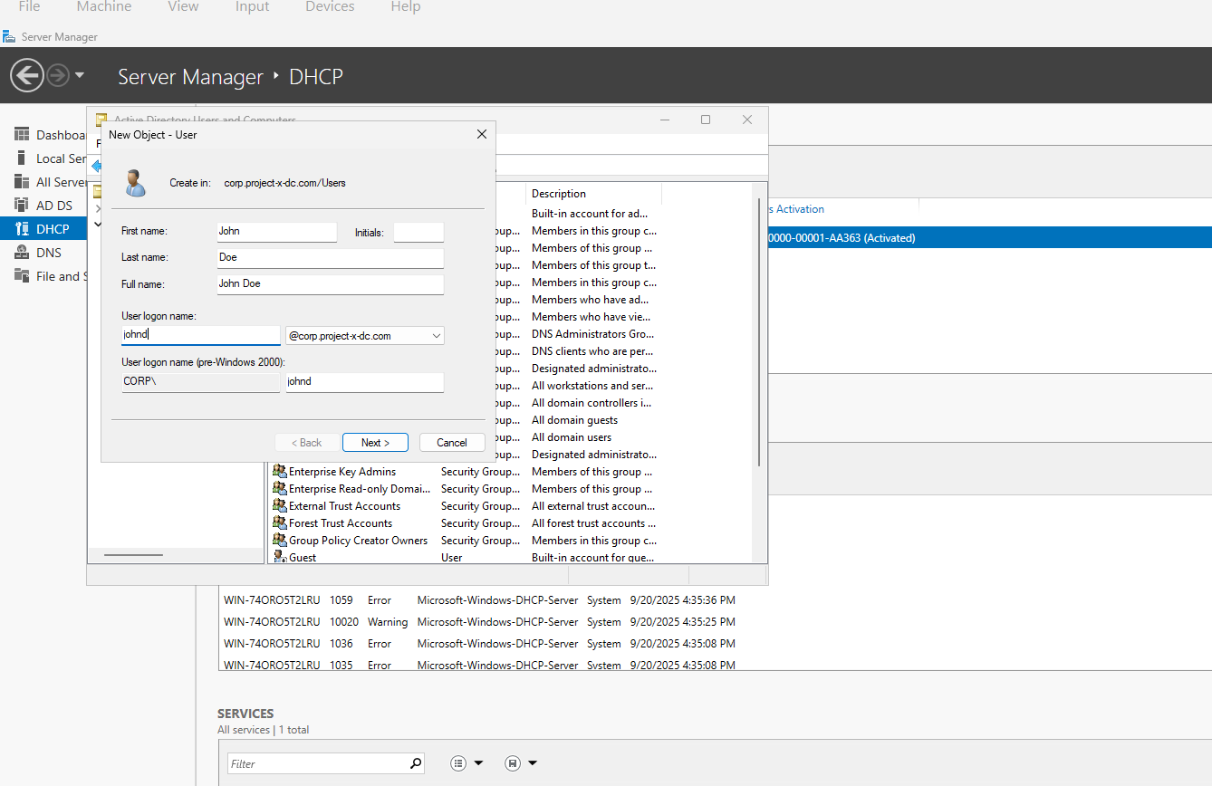

11. Take Snapshot

- VM → Machine → Take Snapshot → Name & Save.

*Saves the VM’s current state, allowing rollback in case of errors or mistakes, ensuring safe experimentation and repeatable lab setups.*

Step 6: Provisioning Windows 11 Enterprise (Enterprise Workstation 1):

1. Create VM

- Name VM, type Microsoft Windows, version Windows 11 (64-bit).

- Memory: 4096 MB, Processors: 2.

- Virtual Disk: 80 GB, default settings.

- Connect VM to NAT network.

*Baseline hardware to run Windows 11 smoothly in the lab.*

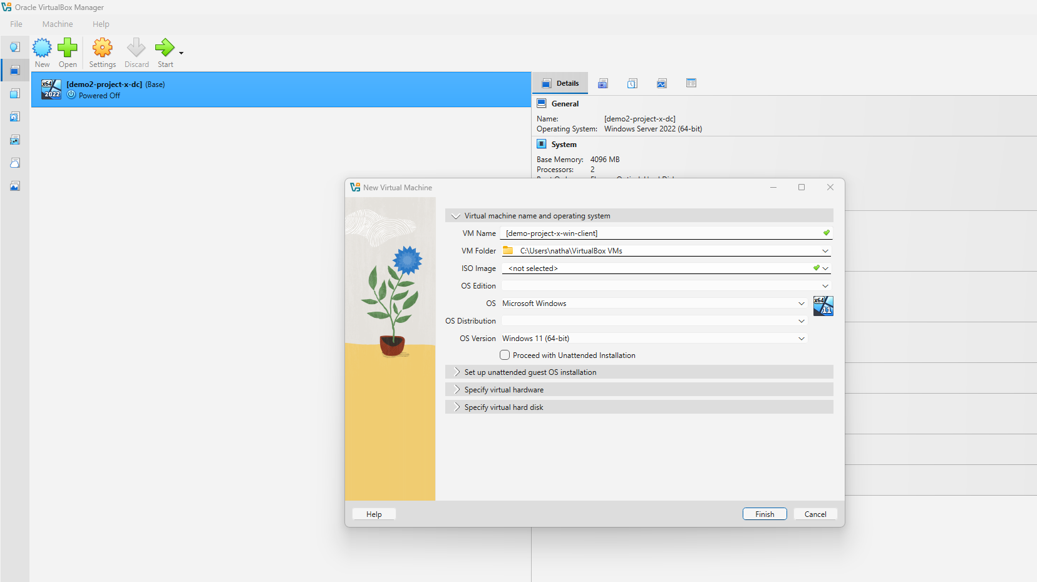

2. Mount ISO & Install OS

- Boot from Windows 11 Enterprise ISO.

- Select language, region, install Windows 11, create new partition (default settings).

- Set local Administrator password.

*Clean installation ensures stable VM setup.*

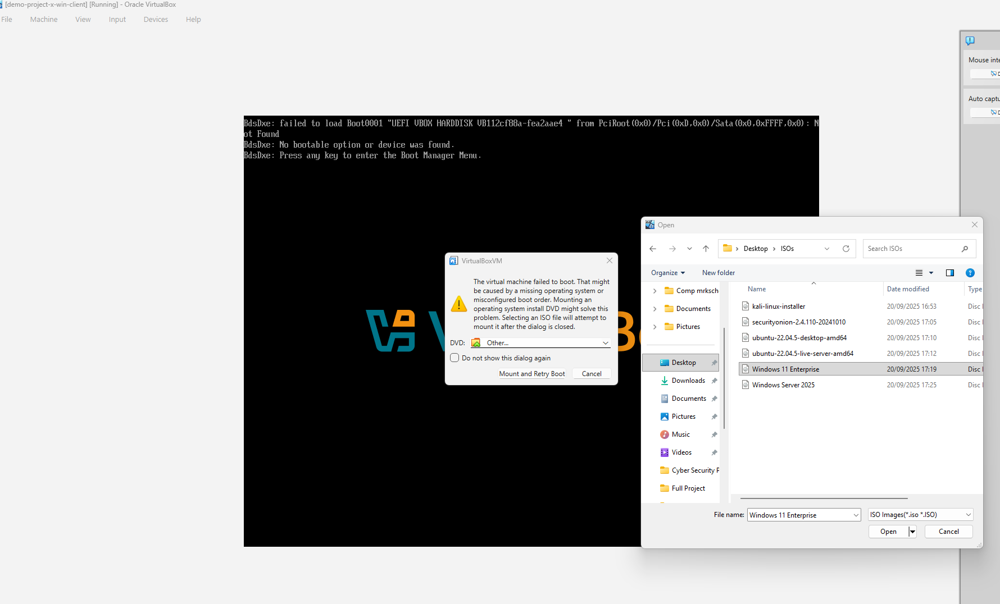

3. Convenience & Usability

- Bypass online account: Switch network to Host-only, open Command Prompt (Shift+F10), run oobe\bypassnro, complete OOBE wizard offline.

- Disable auto logoff & Ctrl+Alt+Del requirement: Settings → Accounts → Sign-in options → Require sign-in → Never; gpedit.msc → Local Policies → Security Options → “Interactive logon: Do not require Ctrl+Alt+Del” → Enabled.

- Install VirtualBox Guest Additions: Devices → Insert Guest Additions CD → Run VBoxWindowsAdditions.exe → Reboot.

- Enable full screen, shared clipboard (bidirectional), drag & drop (bidirectional).  
*Simplifies setup and improves interaction with host for efficiency.*

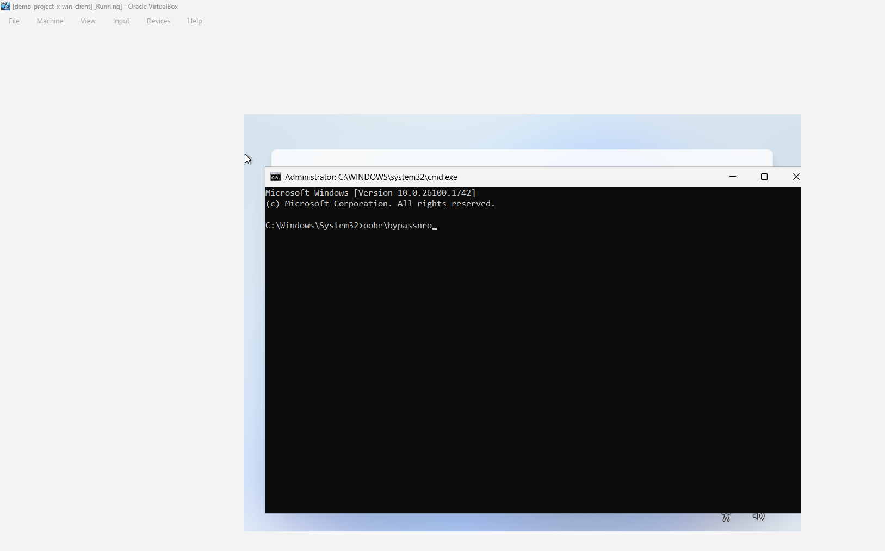

4. Assign Static IP

- IPv4: 10.0.0.100, Subnet: 255.255.255.0, Gateway: 10.0.0.1, DNS: 10.0.0.5  
*Ensures predictable connectivity with domain controller and lab resources.*

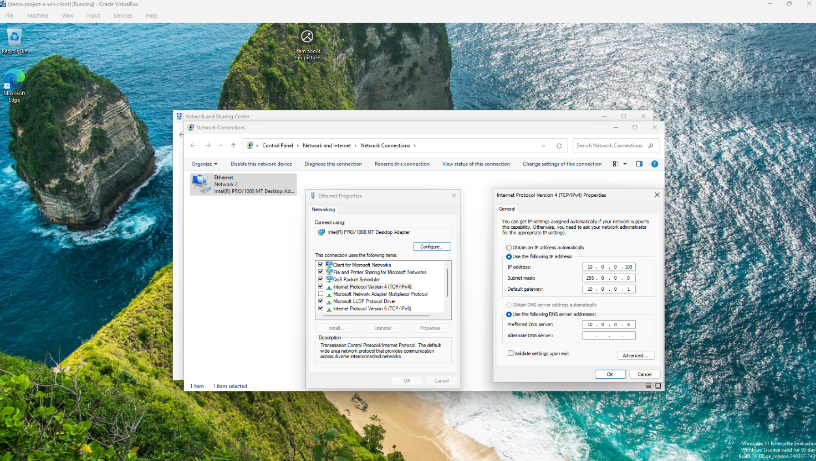

5. Join Domain & Configure Computer

- Rename VM (e.g., project-x-win-client).

- Join domain: corp.project-x-dc.com using AD user johnd.

- Reconnect to NAT network and restart.

*Adds VM to managed network, granting access to domain resources and applying AD policies.*

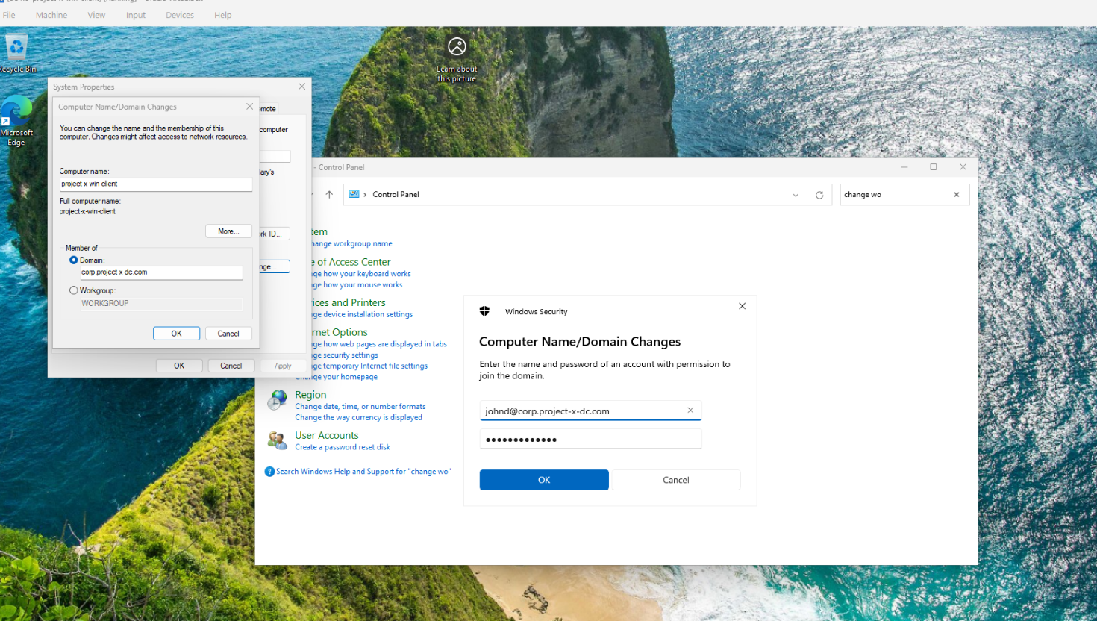

6. Snapshot

- Take VM snapshot after setup.

*Allows rollback in case of misconfiguration or testing errors.*

Step 7: Provisioning Ubuntu VM (Enterprise Workstation 2):

1. Create VM

- Name VM, type Linux, version Ubuntu 22.04 LTS (64-bit).

- Memory: 2048 MB, CPU: 1.

- Virtual Disk: 80 GB, default settings.

- Connect to NAT network.

*Baseline hardware to run Ubuntu for lab tasks.*

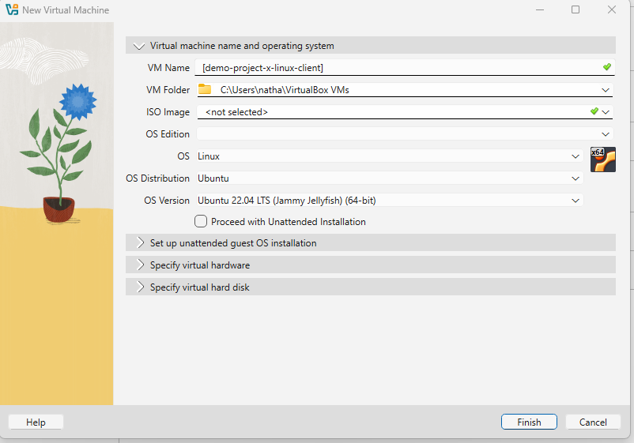

2. Mount ISO & Install OS

- Boot from Ubuntu 22.04.5 Desktop ISO, install with default options.

- Create partitions (default settings), set local user (Jane Doe).

- Skip online accounts, Ubuntu Pro, and location services. Disable screen blanking.

*Clean installation ensures stability and local offline setup.*

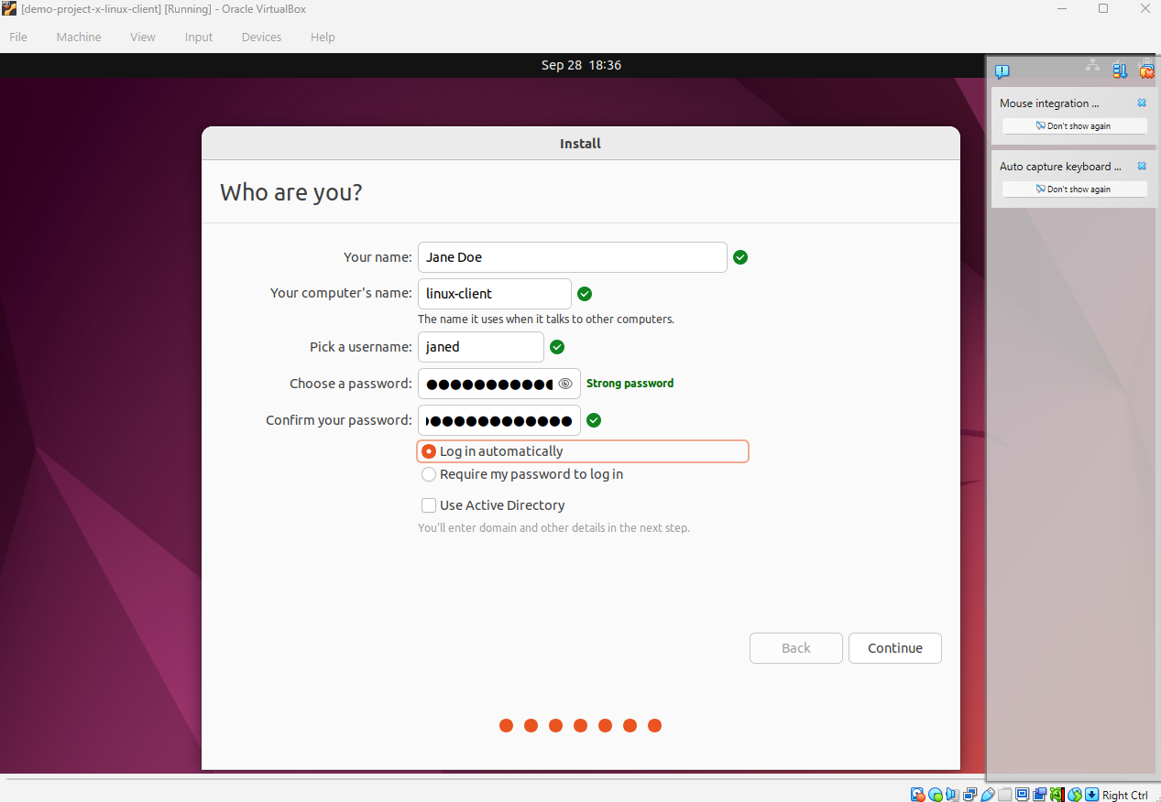

3. Assign Static IP

- IPv4: 10.0.0.101, Subnet: 255.255.255.0, Gateway: 10.0.0.1, DNS: 10.0.0.5

*Ensures predictable network address and connectivity with domain controller.*

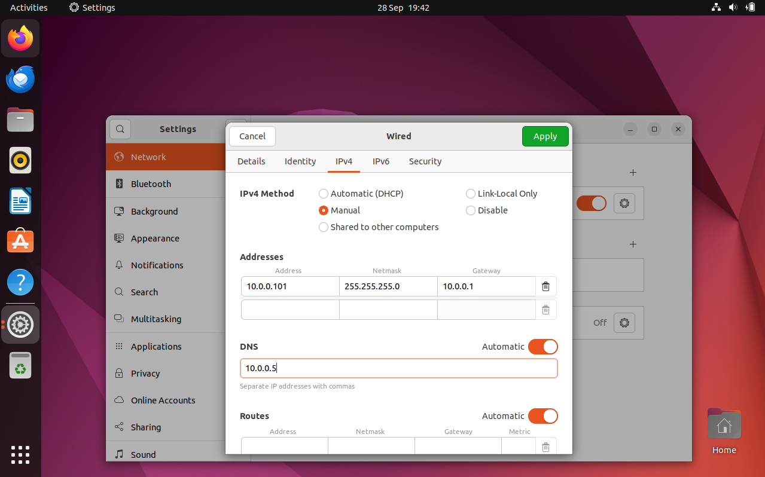

4. Join Active Directory Domain

- Install required packages: winbind, libpam-winbind, libnss-winbind, krb5-config, samba modules.

- Configure Samba: /etc/samba/smb.conf with realm, workgroup, Kerberos, ADS security, Winbind settings.

- Update /etc/nsswitch.conf to include Winbind in passwd and group.

- Enable home directory creation for domain users via sudo pam-auth-update.

- Update DNS to point to AD server (10.0.0.5).

- Join domain: sudo net ads join -U Administrator, restart Winbind: systemctl restart winbind.

*Integrates Linux workstation with Active Directory for centralised authentication and domain resource access.*

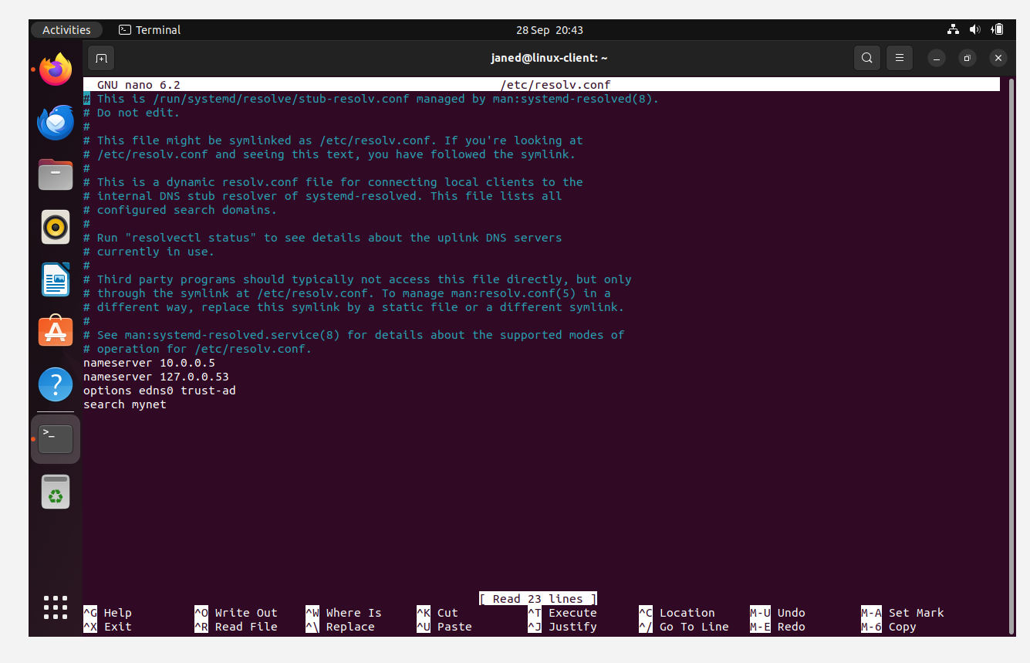

5. Convenience & Usability

### - Set screen blanking to never via Ubuntu settings.

### - Install VirtualBox Guest Additions (Devices → Insert Guest Additions CD → Run installer).

### *Improves usability by preventing screen lock and enabling full screen, shared clipboard, and drag/drop functionality between host and VM.*

6. Test AD Connectivity & Login

- Verify users: wbinfo -u, check domain info: net ads info.

- Login as domain user: CORP+janed, creates /home/CORP/janed.

- Confirm connection on Domain Controller → Active Directory Users and Computers → Computers shows Linux client.

*Confirms successful domain join, user authentication, and home directory creation.*

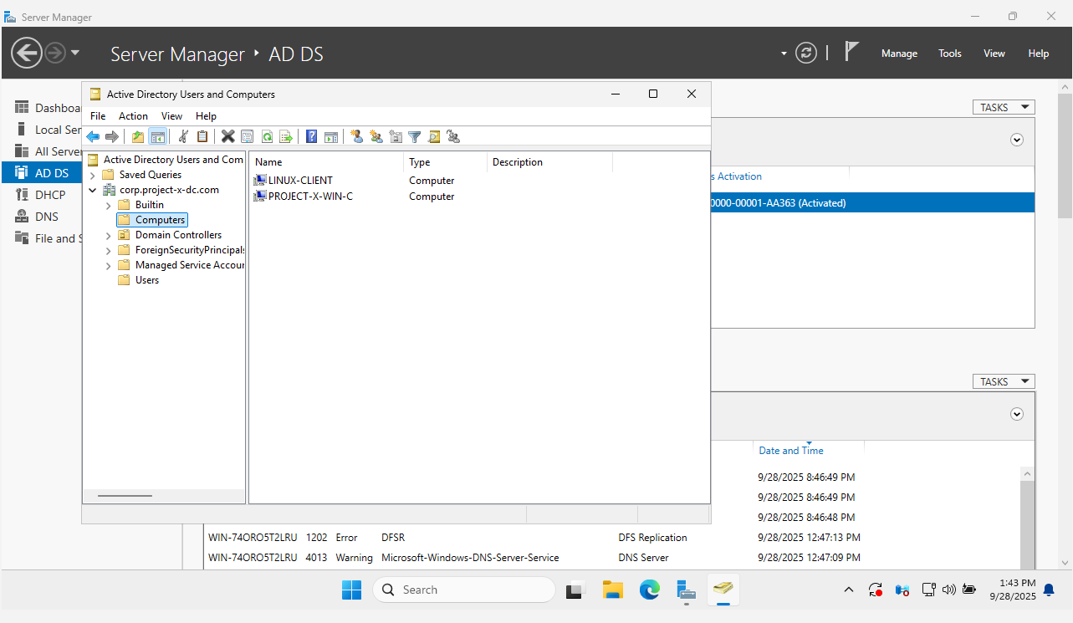

7. Snapshot

- Take VM snapshot after setup.

*Allows rollback in case of misconfiguration or testing errors.*

Step 8: Provisioning Ubuntu VM (Security Server 1/Corporate Server):

1. Clone VM

- Clone Ubuntu Desktop VM from Step 7.14 (Enterprise Workstation 2).

*Saves time and ensures consistency by reusing preconfigured OS and dependencies.*

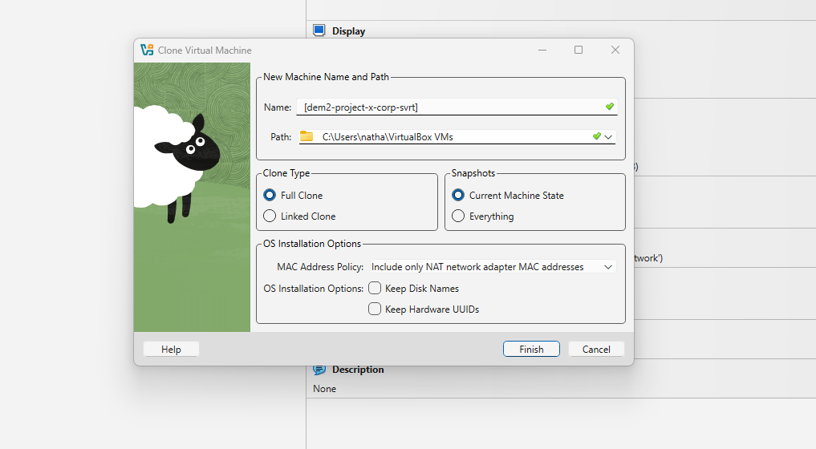

2. Configure VM

- Set static IP: 10.0.0.8 (outside DHCP range).

- Set hostname: corp-svr (sudo hostnamectl set-hostname corp-svr).

- Create administrative user: project-x-admin, add to sudo group.

*Ensures predictable network identity, domain integration, and secure administration.*

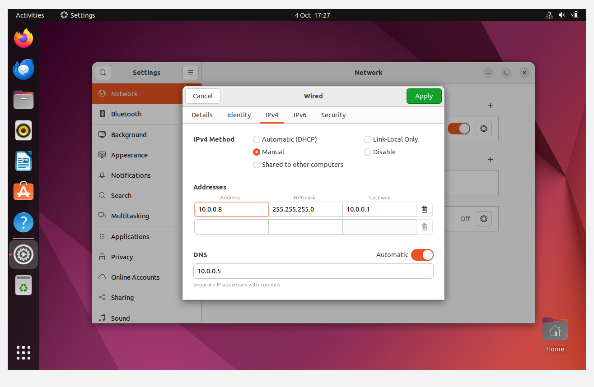

3. Join Active Directory Domain

- Ping DC to confirm connectivity.

- Join domain: sudo net ads join -U Administrator.

- Log in to generate home directory: CORP+Administrator.

*Integrates server with AD for authentication, group policies, and domain services.*

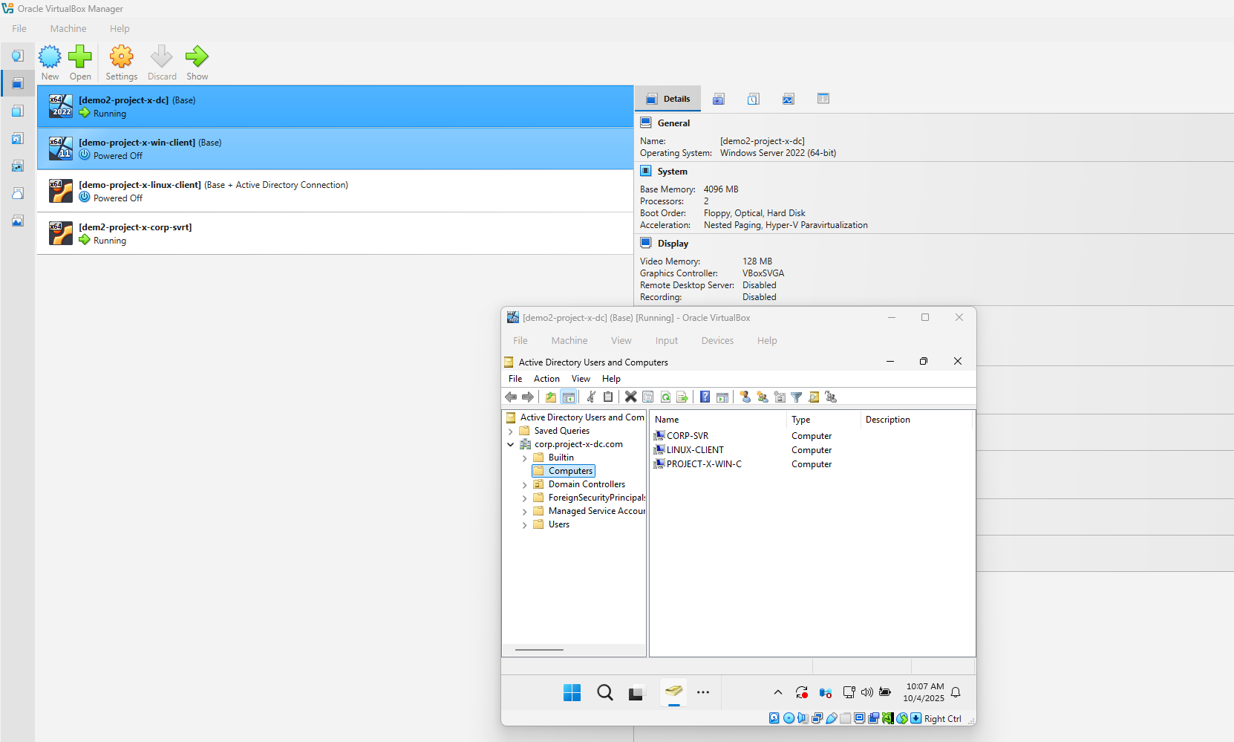

4. Convenience & Usability

- Skip Ubuntu setup wizards, set screen blank to never.

### - Install VirtualBox Guest Additions (Devices → Insert Guest Additions CD → Run installer).

### *Improves usability by preventing screen lock and enabling full screen, shared clipboard, and drag/drop functionality between host and VM.*

5. Install Docker

- Install via apt repository (per official instructions). <https://docs.docker.com/engine/install/ubuntu>

- Test installation: sudo docker run hello-world, sudo docker ps -a.

*Enables containerised services (email, DNS, FTP) in isolated environments for secure administration.*

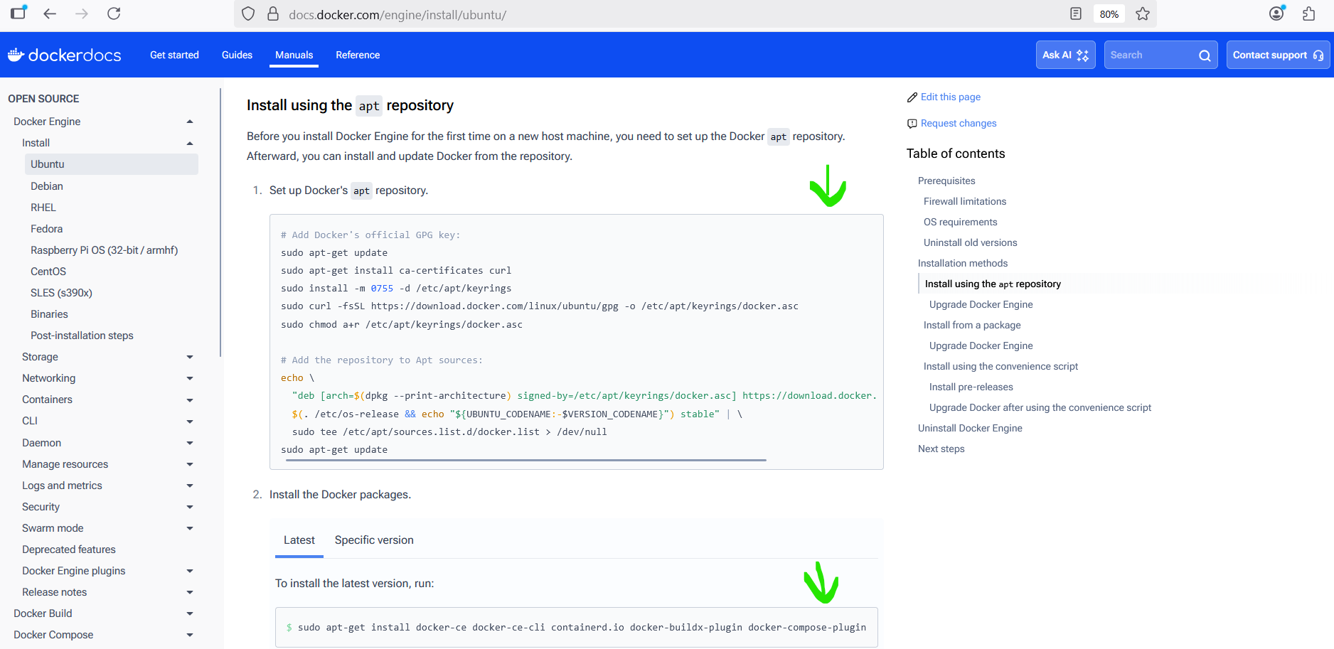

6. Snapshot

- Take VM snapshot after configuration.

*Allows rollback in case of misconfiguration or testing errors.*

Step 9: Install Mailhog on Security Server 1:

### 1. Set Up MailHog

### - On Security Server 1 VM:

### cd /home sudo mkdir mailhog cd mailhog sudo nano docker-compose.yml

- Paste Docker Compose config:

version: "3"  
services:  
 mailhog:  
 image: mailhog/mailhog  
 container_name: mailhog  
 ports:  
 - "1025:1025"  
 - "8025:8025"

- Start container: sudo docker compose up -d

*Runs a lightweight, isolated SMTP server to safely capture and inspect emails.*

2. Test MailHog Locally

- Create test email script test_message.py, make executable and run:

sudo chmod +x test_message.py  
sudo python3 test_message.py

- Open dashboard: [http://localhost:8025](http://localhost:8025/)

*Verifies container captures emails correctly within the lab.*

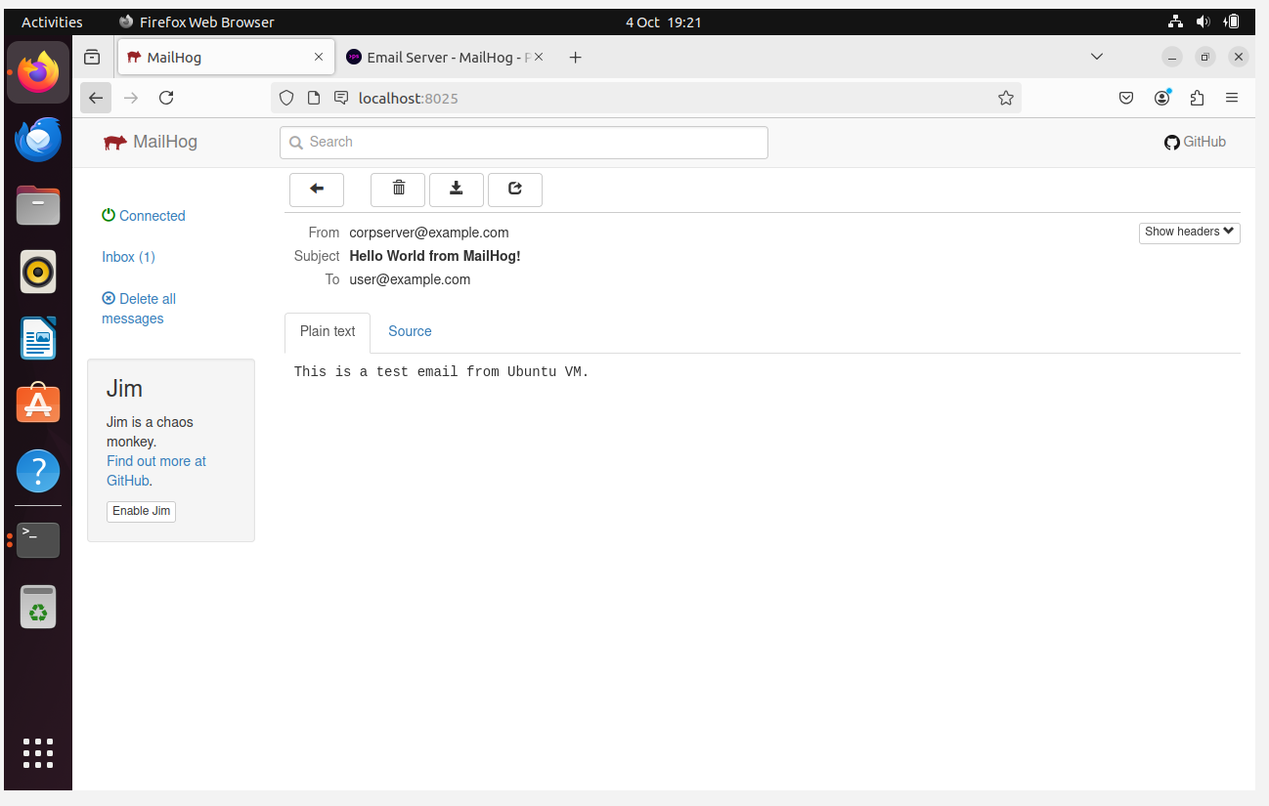

3. Poll Emails from Linux Client

- Create polling script email_poller.sh, install dependencies:

sudo apt update  
sudo apt install curl jq -y  
sudo chmod +x email_poller.sh  
./email_poller.sh &

- Script continuously monitors MailHog and displays new messages.

*Ensures Linux client can safely receive and display emails from MailHog.*

### 4. End-to-End Test

### - Update test_message.py to target Linux client user and run.

### - Verify dashboard and client output show new email.

*Confirms cross-VM email delivery within the lab.*

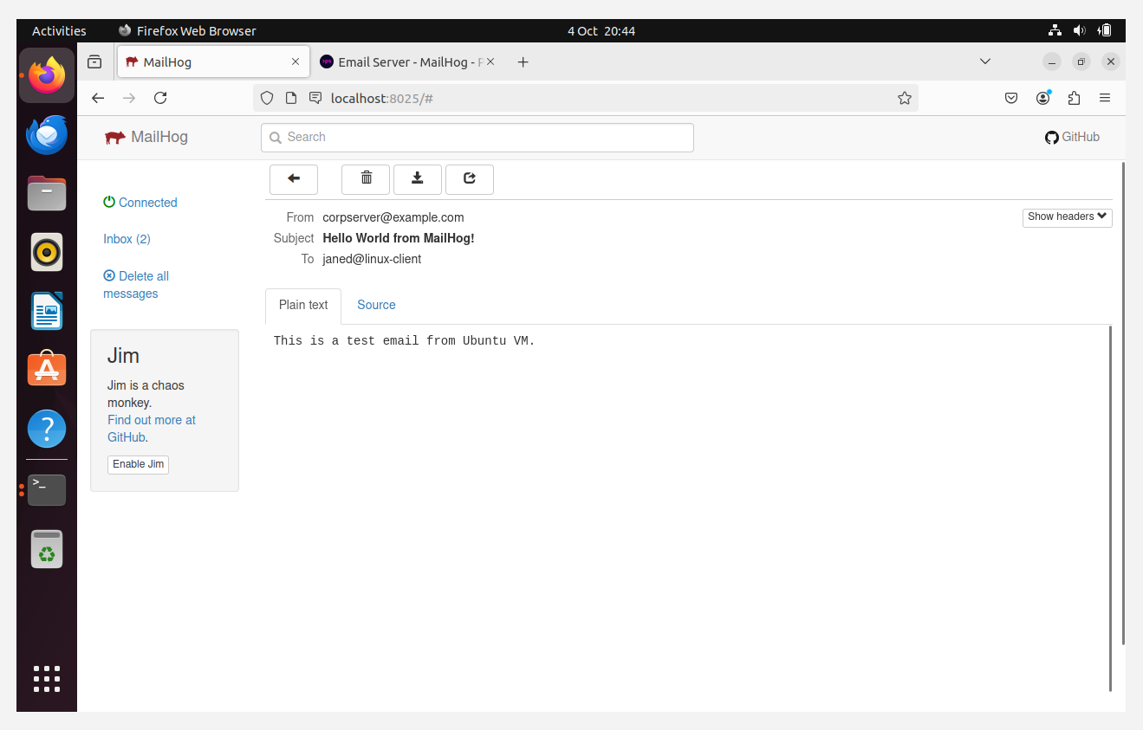

5. Take Snapshot

### - Snapshot Security Server 1 VM in VirtualBox.

*Preserves MailHog setup for quick rollback or restoration.*

Step 10: Provisioning Security Onion VM (Security Workstation):

1. Create Security Onion VM  
  
- Name: demo-project-x-sec-work

- Type: Linux, Version: Oracle Linux (64-bit)

- Memory: 2048 MB, CPU: 1

- Disk: 55 GB

- Connect to NAT network

*Baseline hardware to run Security Onion for network monitoring.*

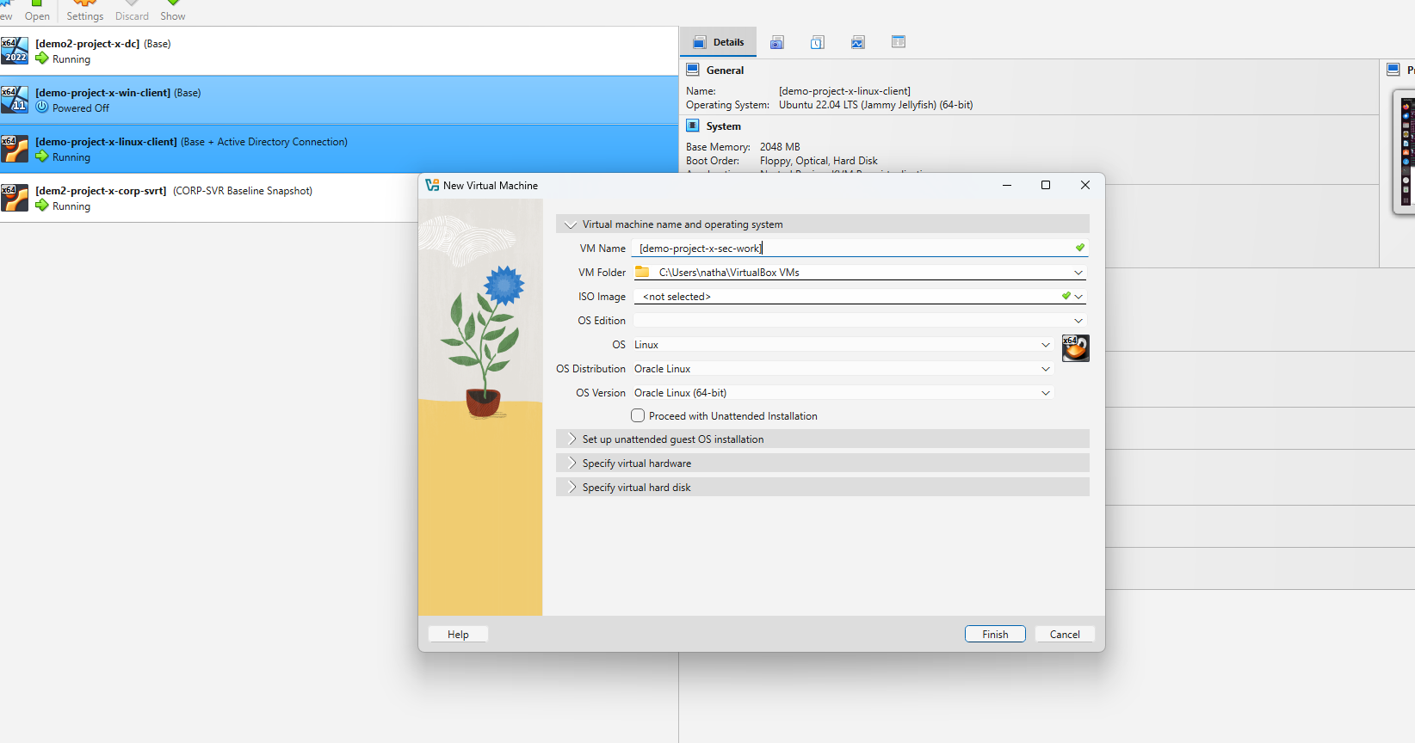

2. Mount ISO & Install OS

- Boot from Security Onion 2.4.110 Desktop ISO

- Localhost login: project-x-sec-work (set password)

- Hostname: project-x-sec-work

- NIC: default, Static IP: 10.0.0.103/24

- Gateway: 10.0.0.1, DNS: default, search domain: corp.project-x-dc.com

- Graphical interface: enabled

- Reboot VM

*Provides a predictable IP and domain configuration for monitoring and ensures GUI access for management.*

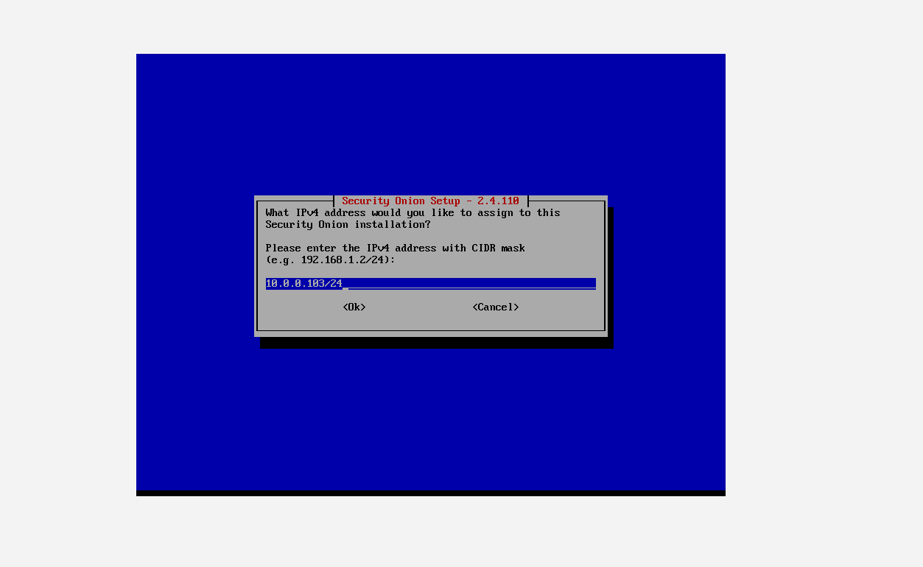

3. Root Password  
  
- Open terminal: sudo passwd root → set new password  
  
*Enables administrative access for Security Onion configuration and management.*  
  
4. Take Snapshot  
  
- Snapshot VM in VirtualBox  
  
*Preserves a working baseline for the Security Onion VM for quick rollback or restoration.*

Step 11: Provisioning Ubuntu Server VM (Security Server 2):

1. Create Security Server 2 VM  
  
- Clone Linux Client VM → rename demo-project-x-sec-box.  
  
- Update hostname: sudo nano /etc/hostname → replace with sec-box, reboot.  
  
- Create new user:  
  
 sudo adduser sec-user (set password)  
  
 sudo usermod -aG sudo sec-user  
  
 Switch to sec-user: su sec-user → verify sudo with sudo whoami.

*Prepares a dedicated Ubuntu Server VM for hosting Wazuh with admin privileges.*

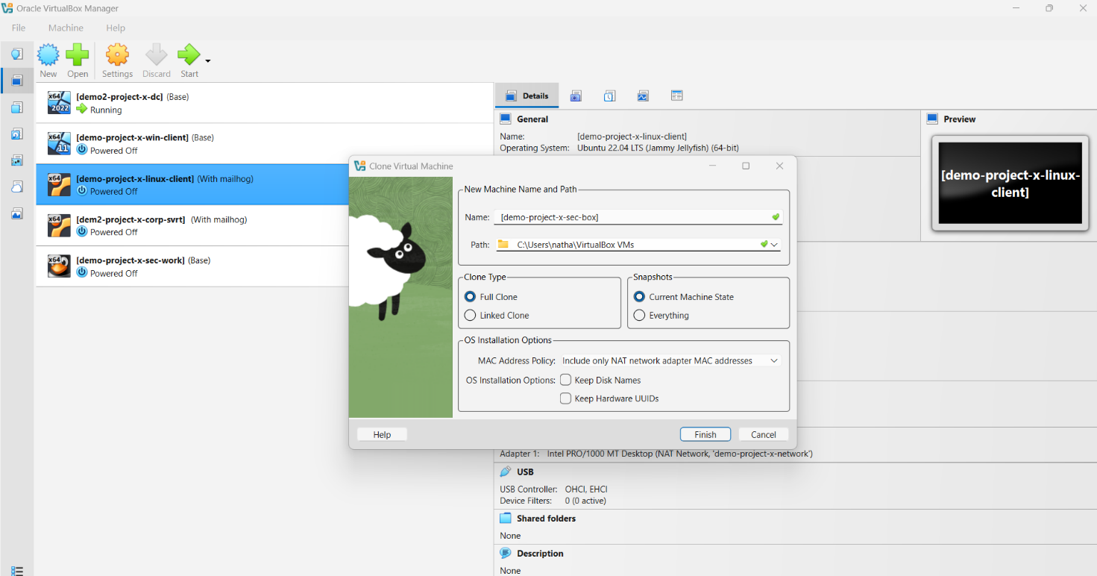

2. Configure Network

- Set static IP: 10.0.0.10.  
  
- Test connectivity: ping 10.0.0.5 and ping corp.project-x-dc.com.

*Ensures server has predictable addressing and communication with AD.*

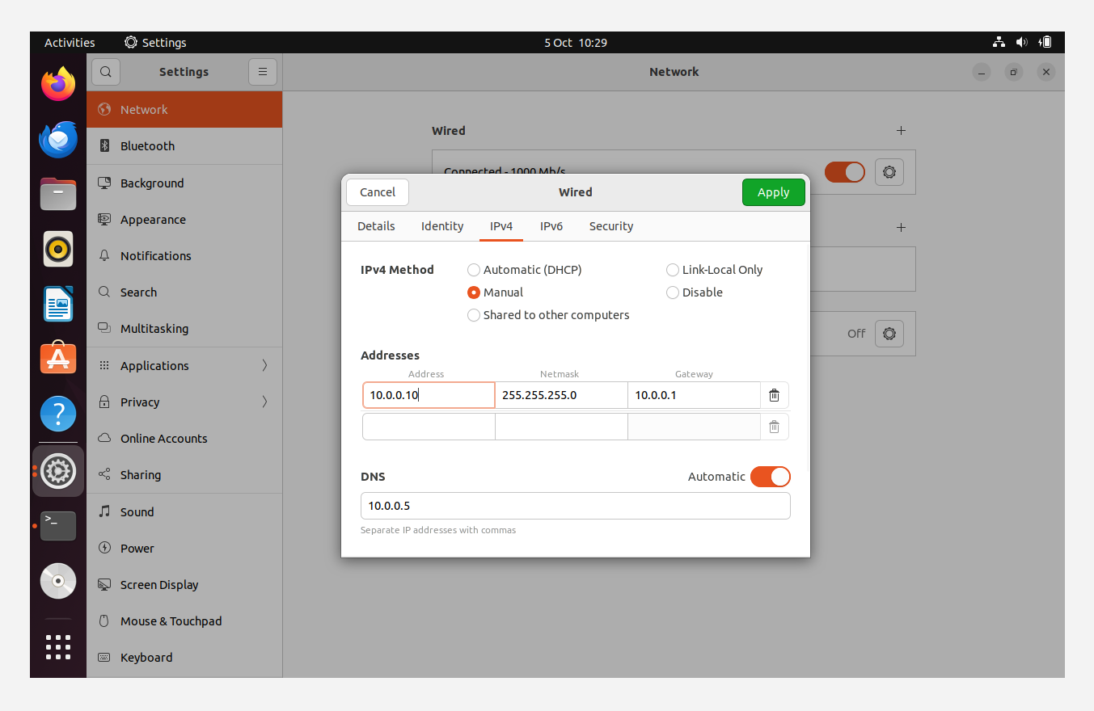

3. Domain Integration  
  
- On Domain Controller: create new AD user + new domain admin group.  
  
- On Security Server 2:  
  
 - Restart winbind: sudo systemctl restart winbind.  
  
 - Join domain: sudo net ads join -U Administrator.  
  
 - Restart winbind again.  
  
 - Verify: wbinfo -u → should display new AD user.

- Test login: sudo login, run id to confirm domain membership.

*Adds Security Server 2 to Active Directory, enabling central authentication and management.*

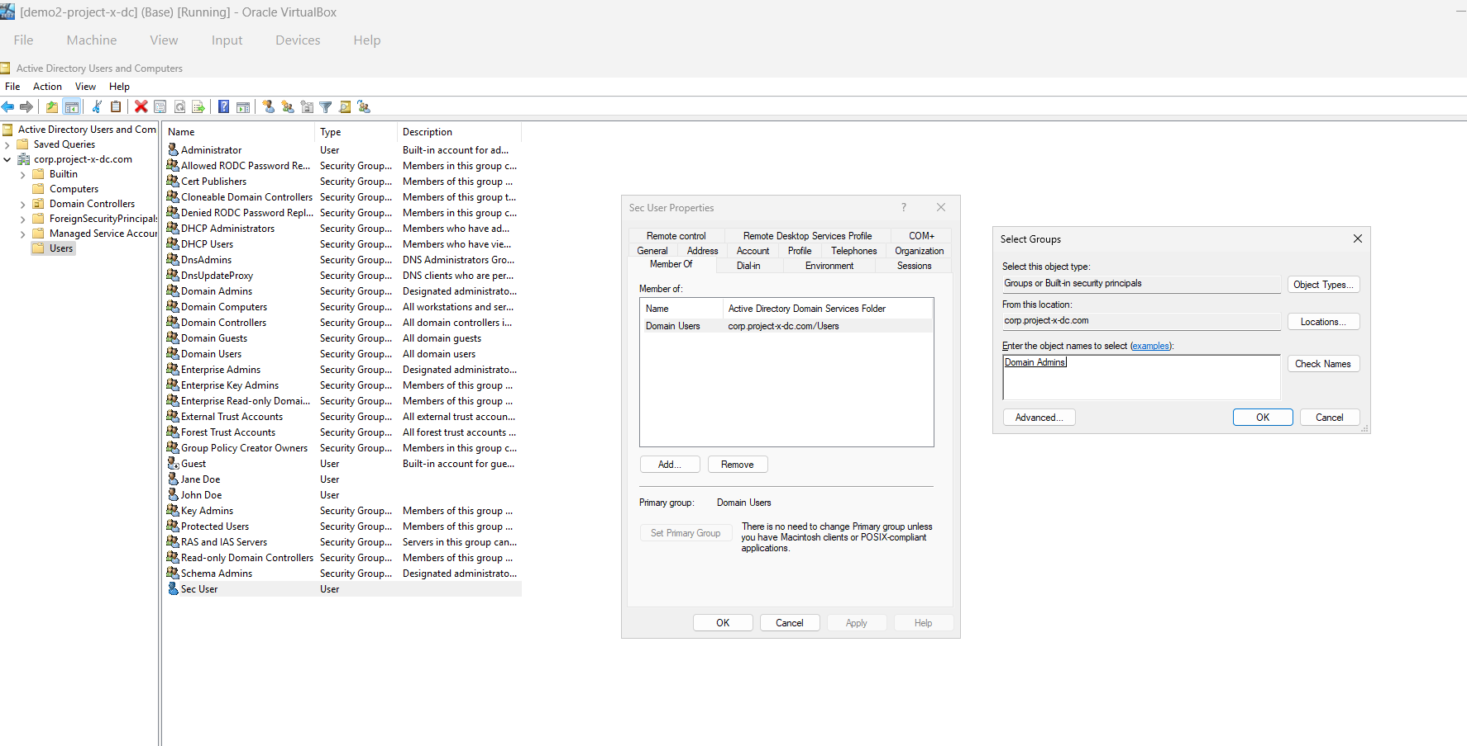  
  
4. Take Snapshot  
  
- Snapshot VM in VirtualBox.  
  
*Saves a stable baseline after successful AD integration.*

Step 12: Installing And Setting Up Wazuh On Security Server 2 VM:

### 1. Prepare Security Server 2 VM

### - Update resources: 4096MB RAM, 2 CPUs, 80GB disk.

### - Start VM, log in as sec-user.

### *Ensures server has enough capacity for Wazuh SIEM/XDR platform.*

### 2. Install Wazuh

### - Install curl: sudo apt install curl (already present on clone).

### - Run installer:

curl -sO https://packages.wazuh.com/4.9/wazuh-install.sh && sudo bash ./wazuh-install.sh -a -i

- Save credentials: nano wazuh-password.txt.

- Access Wazuh UI at http://localhost, log in with generated user/password.

*Installs Wazuh manager and web interface.*

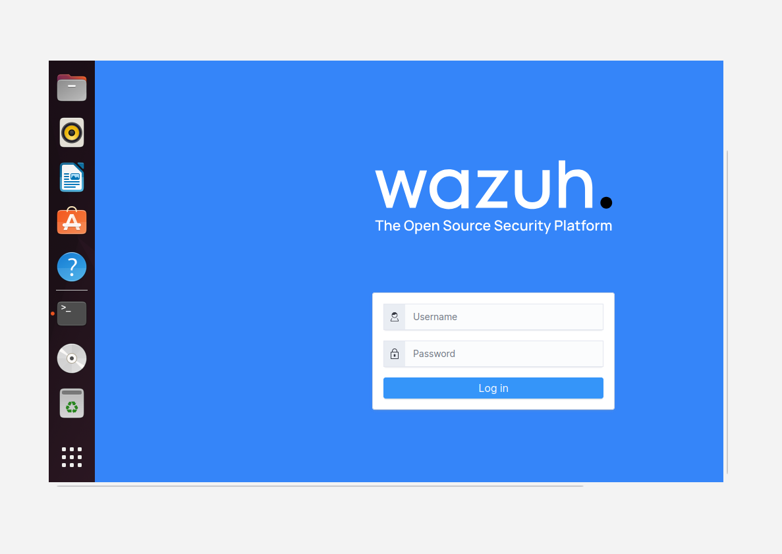

3. Deploy Agents

- Windows Workstation:

- Wazuh → Server Management → Endpoints → Deploy Agent → Windows.

- Server: 10.0.0.10, Agent: project-x-win-client.

- Run generated PowerShell commands on Windows client (as admin).

- Start service: NET START Wazuh.

- Confirm in Wazuh dashboard.

- Take snapshot of Windows client.

- Linux Client:

- Deploy new agent → Linux DEB amd64.

- Server: 10.0.0.10, Agent: project-x-linux-client.

- Run generated command on Linux client terminal.

- Confirm in dashboard.

- Take snapshot of Linux client.

- Domain Controller:

- Repeat Windows agent steps on DC VM.

*Connects all lab systems to Wazuh for centralised log collection.*

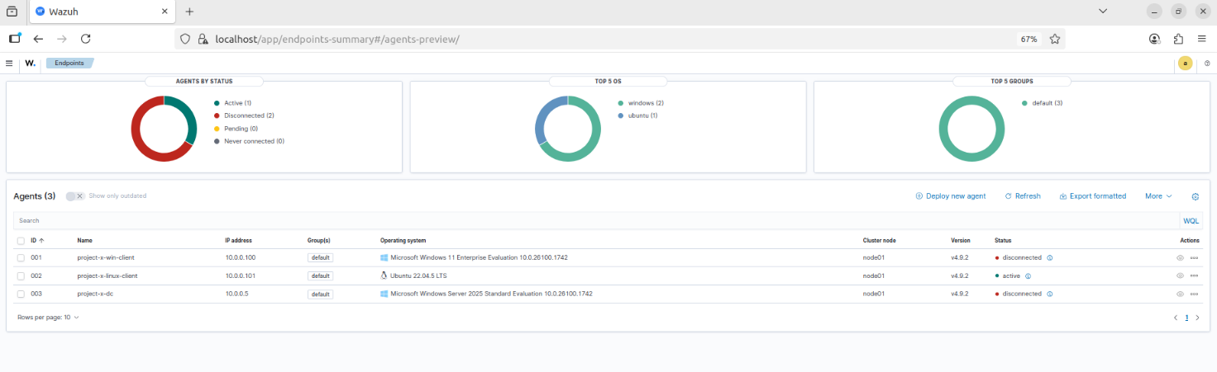

### 4. Organise Agents

### - Create groups in Wazuh: Windows and Linux.

### - Assign agents to respective groups.

### *Groups allow applying OS-specific configurations.*

### 5. Configure Agent Logs

- Windows (agent.conf):

<agent_config>

<!-- Shared agent configuration here -->

<localfile>

<location>Security</location>

<log_format>eventchannel</log_format>

</localfile>

<localfile>

<location>Application</location>

<log_format>eventchannel</log_format>

</localfile>

</agent_config>

- Linux (agent.conf):

<agent_config>  
 <localfile>  
 <log_format>syslog</log_format>  
 <location>/var/log/auth.log</location>  
 </localfile>  
 <localfile>  
 <log_format>syslog</log_format>  
 <location>/var/log/secure</location>  
 </localfile>  
 <localfile>  
 <log_format>audit</log_format>  
 <location>/var/log/audit/audit.log</location>  
 </localfile>  
</agent_config>

*Ensures native logs (eventchannel, syslog, audit) are collected per OS.*

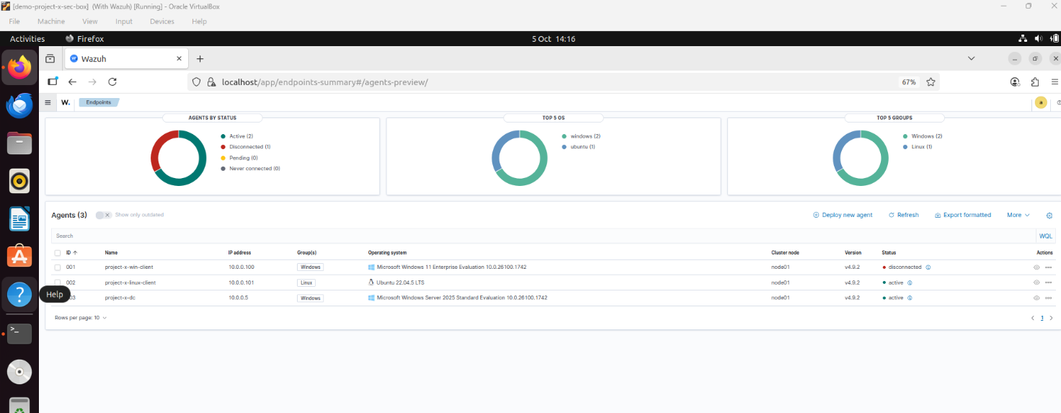

### 6. Verify & Snapshot

### - Confirm logs appear in Wazuh dashboard.

### - Take snapshots of Security Server 2 VM and all agents.

### *Establishes a clean baseline with Wazuh fully deployed and agents reporting logs.*

